TAGORE DENTAL COLLEGE AND HOSPITAL
DEPARTMENT OF ORAL PATHOLOGY

PROGRAM CATEGORY | Guest Lecture
TOPIC | Fibro Osseous Lesion
DATE | 18/06/2021
DAY | Friday
VENUE | Google meet
ORGANIZERS | Department of Oral Pathology, Tagore Dental College & Hospital.
NUMBER OF PARTICIPANTS | IV BDS – 84 students
RESOURCE PERSON | Prof. Dr. Sathick Manzoor, MAHSA University

Principal Head of the Department

TAGORE DENTAL COLLEGE AND HOSPITAL
DEPARTMENT OF ORAL AND MAXILLOFACIALPATHOLOGY

GUEST LECTURE REPORT – 18.06.21

Guest lecture on “Fibro osseous lesions” by Prof. Dr. Sathick Manzoor MDS, Senior Lecturer, MAHASA University was organized by Department Of Oral Pathology, Tagore Dental College and Hospital as a part of International webinar series with MAHSA University in the final google class link (https://meet.google.com/uym-aidr-buk). The lecture was attended by 84 final year students (Regular and Additional batch). Introduction, classification, clinical, radiographic and histopathology and treatment modalities for fibro osseous lesions was enlightened by the speaker.

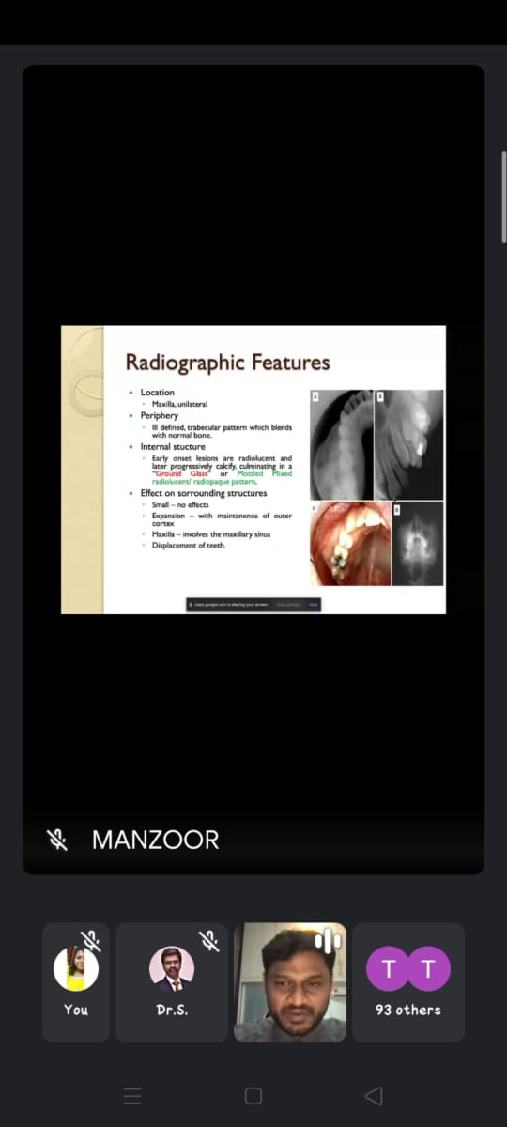
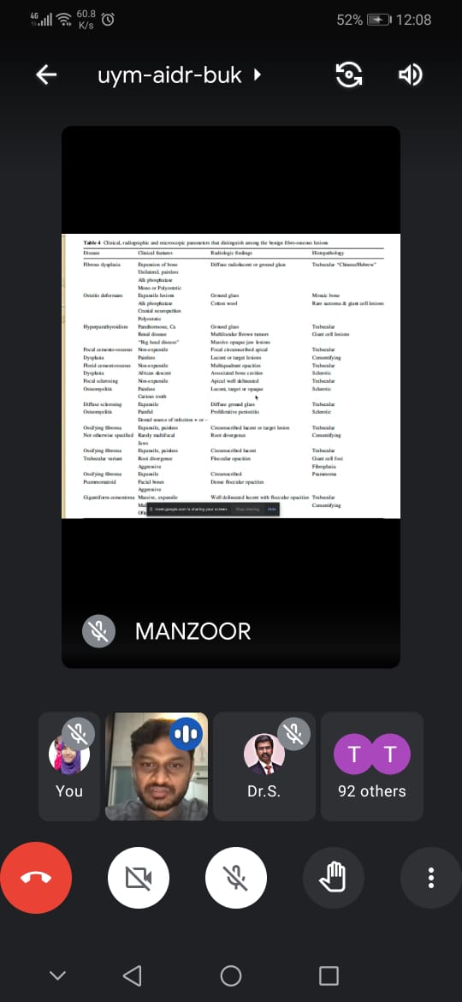
PHOTO GALLERY

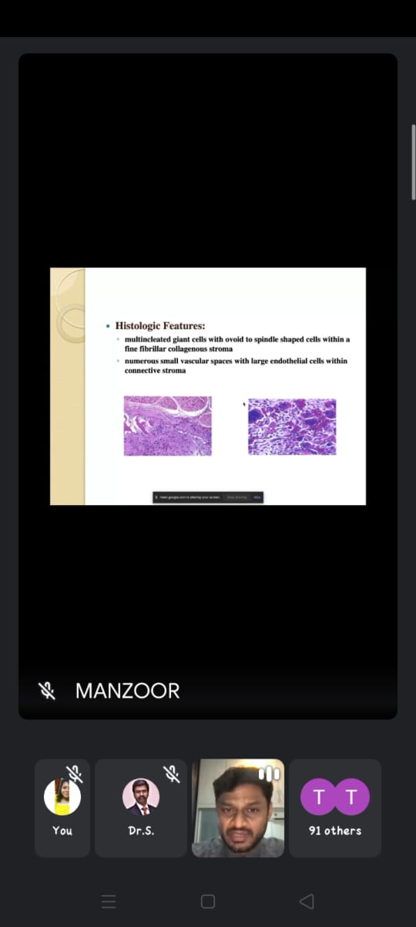

ATTENDANCE PARTICULARS
- AARTHI P
- AARUDRADEVI J G
- AISHWARYA K
- AISHWARYA S
- AJAI KUMAR
- AJITH KUMAR S
- AKASH V
- AKSHAYA N
- ANITHA ROSELIN S
- ANJALI V
- ANUSIYA J
- ASHWINI D
- AYISHA M
- BAKYA LAKSHMI V
- BALAJI S A
- BHARANY MALAVIKA J
- BHARGAVI T
- BHAVANKUMAR V
- DEEPAK RAJ J
- DEEPIKA BARATHI M
- EZHIL BHARATHI I
- FATHIMA HASEEN FAZEENA
- GAYATHRI V A M
- GOKULA PRIYA R
- GOPINATH B
- GOWARDHAN S
- HARITHA R
- JANANEE BHARKAVI N
- JANISHA M
- JEBASELVI P
- JEYAMITHA R
- KALKI PRIYA A
- KALPITA DEB BARMAN
- KAMIL HANNEF
- KANMANI R
- KARTHIKEYAN A
- KRISHNAPRIYA R
- KRITHIKA A
- LAKSHAYAA C M S
- MALARVIZHI G
- MARIA SELVA VIVETHA A
- MONISHA N C
- MUTHU MEENAL M
- NAFEESA A
- NIRMALA S
- NISHA DAPHNE R
- NISHAALI M M
- PAVITHRA M
- POOJA DHARSHINI R
- PRAVINA
- PREETHA J H
- PRIYA S
- PUVITHA A
- RAGAPRIYA
- RAJSREE
- RAKSHNA N
- RAMYA M
- RESHMA S
- RITHIKA SRI S
- SAROJINI M S
- SETHU SREE G
- SHARMILA E
- SHREEYAN NAYAR M N
- SHRIKAVI M
- SIVARANJANI S
- SREE LAKSHMI S
- SRIDEVI S
- SRIJANANI S
- STAVAN V
- SUBASH B
- SUBASH M
- SUGUMARI V
- SUMAIYA B
- SUMAIYA FATHIMA T
- SUNIL KUMAR
- SUTHAMANCHARRI S
- THILAKRAJ S
- VASANTHAN R M
- VETHIKA K
- VIVETHA

Additional batch
Present:

1. SUDESH
2. Avinash moorti
3. Diwakar
4. Revathi

